Midterm questionnaires’ databases

To facilitate the consultation of the midterm questionnaires’ results, a series of databases and tables were created, regrouping different kind of data.
The core documents include:
- Four databases, which cover all the information available in the questionnaires (“Implementation steps_db.xlsx”, “Contextual Questions_db.xlsx”, “Vital Statistics_db.xlsx”, “Numeric_db.xlsx”)
- Two summary tables on specific subjects, already covered in the databases (“Vital Statistics_summary.xlsx”, “Verbal autopsy.xlsx”)
- A summary table covering the different targets, in the format used for the “Getting every one in the picture” report, which also contains data for countries that have not answered the midterm questionnaire (“Report_summary_tables.xlsx”).
To use these databases, it is better to be familiar with the midterm questionnaire format first. The template of the questionnaire can be found here, while the questionnaires filled by countries have been published here. The questionnaire and database will be presented side-by-side in this document.

- Implementation steps_db.xlsx
Each questionnaire has 5 sheets with data filled by country in it. This document provides all data filled in the first of them “1. Implementation Steps”, regarding the status and details of 5 of the 8 Regional Action Framework’s steps.
Figure 1: Midterm questionnaire, sheet “1. Implementation Steps”
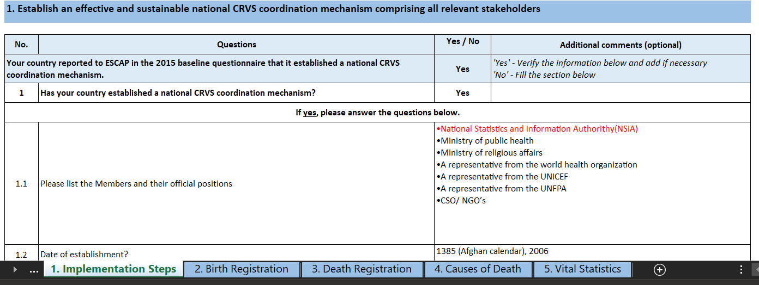

Figure 2: Database “Implementation steps_db.xlsx”
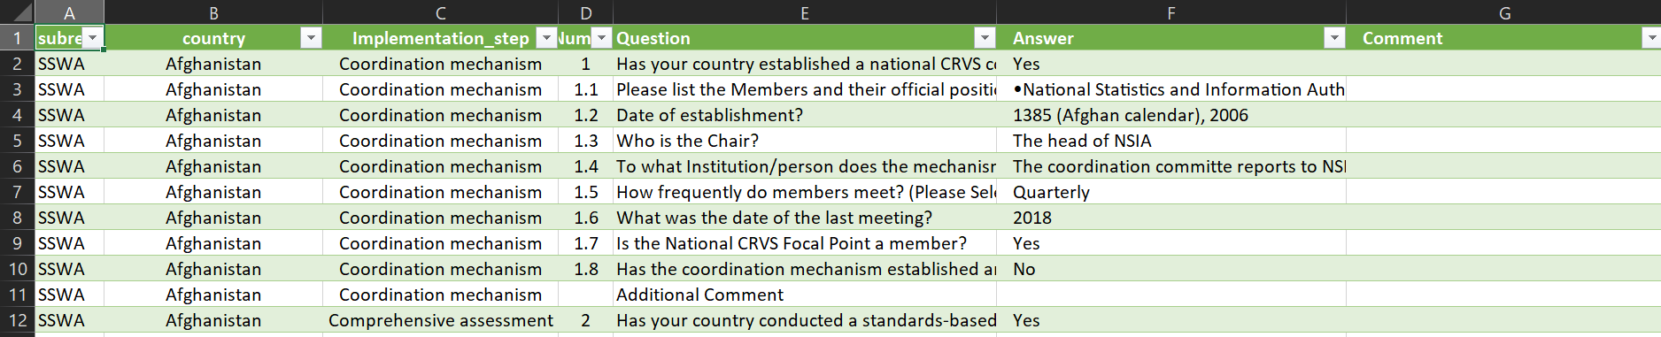
Subregion (Column A):
ESCAP subregion of the country (ENEA, NCA, Pacific, SEA, SSWA and Non-regional).
Country (Column B):
Countries which submitted data relevant to this table with the baseline and/or midterm questionnaire. Corresponds to some of the 62 ESCAP Member States and Associate Members. This is common to all databases.
Implementation_step (Column C)
The implementation step of the Regional Action Framework to which the question refers. Questions were asked regarding five of them: Coordination mechanism (corresponding to question starting with 1.), Comprehensive assessment (2.), National strategy (3.), Reporting plan (4.) and Inequality assessment (5.).
Number (Column D)
It corresponds to the column “No.” on the left of this page of the questionnaire.
Question (Column E)
The text of the question itself.
Answer (Column F)
Corresponds to what can be found under the column “Yes/No” in the questionnaires.
Comment (Column G)
Corresponds to the “Additional comments” column of the questionnaire. Please note that for questions that are not in the “Yes/No” form, such as questions 1.1 and 1.2 above, there is no distinction between “Answer” and “Comment” and the whole answer is to be found in the “Answer” column.
Each step except Inequality assessment also has an “Additional comments” cell under it. The information provided here is reported in the non-numbered “Additional Comment” question of each of these steps.
Figure 3: Midterm questionnaire, sheet “1. Implementation Steps”, Additional comments
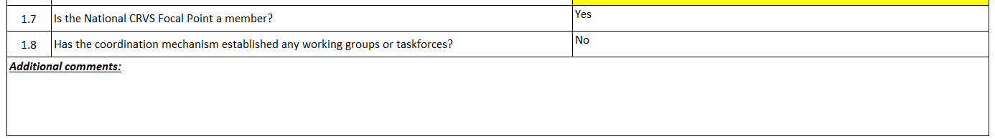
Like for the following databases, all of these variables can be used to filter the database, to showcase answers only from one country or to one answer in particular for example.

- Vital_statistics_db.xlsx
This database showcases data provided by countries regarding their vital statistics targets and their status, in the “5. Vital Statistics” sheet of the questionnaire.
Figure 4: Midterm questionnaire, sheet “5. Vital Statistics”
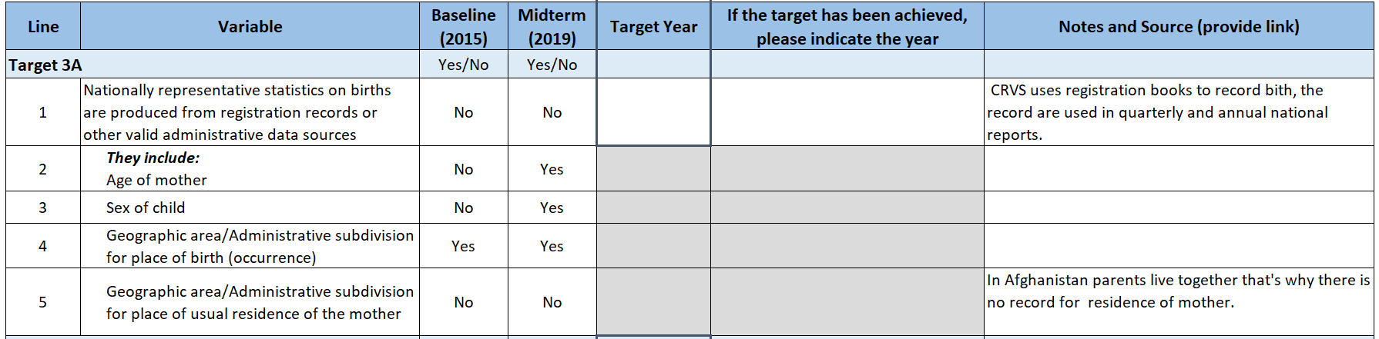
Figure 5: Database “Vital Statistics_db.xlsx”
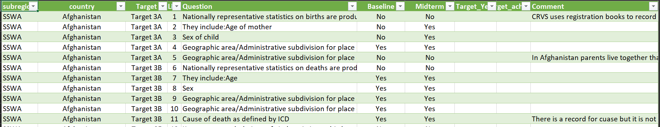
Target (Column C)
Target assessed. There are 5 Vital statistics targets from the RAF: Target 3A (Lines 1-5), 3B (6-11), 3F (12-16), 3G (17-21) and 3H (22-25). The first line of each target represents the status of the target itself, and the following ones the availability of different disaggregations.
Line (Column D)
Contains these line numbers.
Question (Column E)
The question text.
Baseline (Column F)
Represents the status of the target or disaggregation at the moment of the baseline (2015) and can be either “Yes” if achieved or “No” if not. The following column “Midterm” is equivalent, looking at the situation in 2019.
Target_Year (Column G)
It contains the year at which the country is or was planning to achieve it. It can also signify that the target has already been achieved. It is filled only for the main targets lines (1, 6, 12, 17 and 22).
Target_achieved (Column H)
It is for countries to specify, if the target is already achieved, when it was reached. It is also filled only for the main lines.
Comment (Column I)
It contains any remark provided in the “Notes and Source” column of the questionnaire.

- Contextual Questions_db.xlsx
The sheets 2, 3, 4 and 5, on birth registration, death registration, causes of death and vital statistics, contain at the bottom a “Contextual questions” section, referencing legal requirements or uses linked to different aspects of CRVS. This database contains the answer to all of these.
Figure 6: Midterm questionnaire, sheet “2. Birth Registration”, Contextual questions
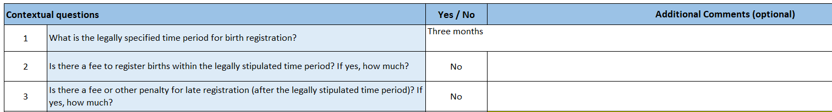
Figure 7: Database “Contextual Questions_db.xlsx”
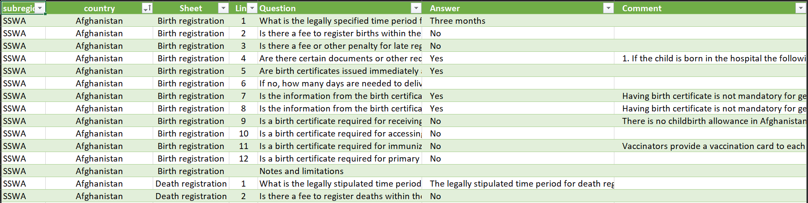
Sheet (Column C)
Which of the four questionnaire excel sheets the question appears in, which corresponds to its general subject.
Line (Column D)
Line number, corresponding to the numbers appearing in the left column of this section of the midterm questionnaire. Similarly to the Implementation steps database, each sheet has a “Notes and limitations” section under these questions, which is reported here without a line number.
Question (Column E)
The question itself.
Answer (Column F)
Corresponds to what can be found under the column “Yes/No” in the questionnaires.
Comment (Column G)
Corresponds to the “Additional comments” column of the questionnaire. Please note that for questions that are not in the “Yes/No” form, such as questions 1 of the birth or death registration sheets, there is no distinction between “Answer” and “Comment” and the whole answer is to be found in the “Answer” column.

- Numeric_db.xlsx
The last database contains all the numerical data, spread over the “2. Birth Registration”, “3. Death Registration” and “4. Causes of death” sheets. Each line of the database corresponds to the value of a variable for a specific year.
Figure 8: Midterm questionnaire, sheet “2. Birth Registration”, data
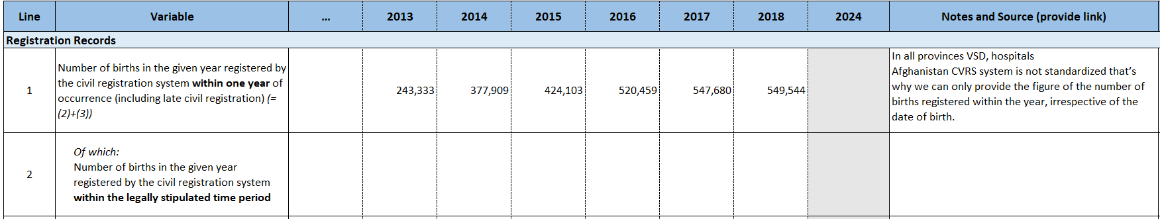
Figure 9: Database “Numeric_db.xlsx”
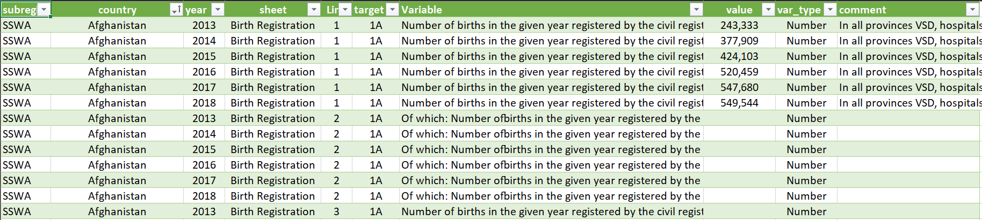

Year (Column C)
The year of the data. By default, it ranges from 2013 to 2018 for each variable, whether countries have provided data or not. However, additional years can be available if countries have submitted data.
The target variables (lines 11 to 14 for birth registration, 7-8 for death registration and 4-5 for causes of death) contain an additional line marked as “2024”, which contains their target value if any.
Lines 15 and 19 of the birth registration sheet, containing to the estimated percentage of children under 5 registered according to the SDG database, and its corresponding estimated number of registered children, appear only if they have a value. Therefore, some countries do not have data, and those that do usually only have one line. Its year can also be out of the usual range.
Figure 10: Midterm questionnaire, sheet “2. Birth Registration”, targets
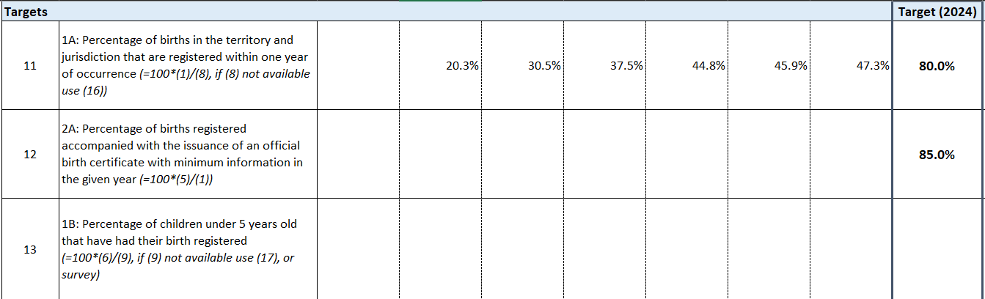
Figure 11: Database “Numeric_db.xlsx”, targets
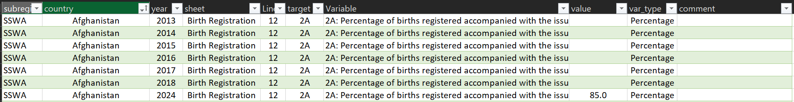
Sheet (Column D)
Midterm questionnaire sheet, which is either birth registration, death registration or causes of death.
Line (Column E)
Corresponds to the number displayed on the left of the table. However, there has been a couple of changes from the questionnaire’s construction. Since target 1A (birth registration, line 11) and target 1D (death registration, line 7) were estimated either with national or international data, and that the two can give quite different results, they were separated. An additional line was therefore created, to display only the internationally estimated completeness. It was given the number 20 of the birth registration sheet for 1A, and 9 of the death registration sheet for 1D.
Figure 12: Database “Numeric_db.xlsx”, target 1A
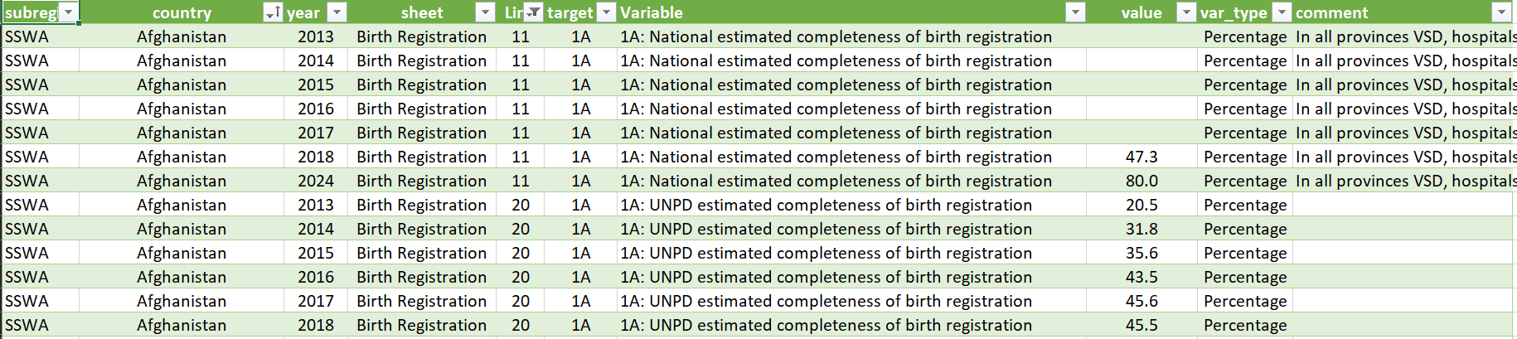
As you can see here for Afghanistan, the figures shown on line 11 of the questionnaire for 2013-2017 are here shown under line 20, since they correspond to international estimates. Only the 2018 estimate is shown on line 11, since it is the only year for which they provided a national estimate. The line 20 shows a different percentage for 2018, which does not appear in the questionnaire. The target for 1A appears under line 11, for 2024.
Additionally, please note that for most countries, the international data and the completeness estimates derived from it in the database slightly differ from what can be found in the questionnaires. This is because a more detailed estimates’ database was found since the creation of the questionnaire and was used to update the estimates. The database should therefore be considered as the proper reference.
target (Column F)
Contains the target of the variable. It is not filled solely for target variables. The other variables have been filled according to the target they can help measure or are related to. For example, if you select target 1A, you will find the lines 1, 2, 3, 4, 8, 11, 16 and 20 of birth registration.
Variable (Column G)
Variable name. Target variables start with their number and letter, such as “1A” and are therefore easy to find.
However, a few changes have again been made from the questionnaire. For the different international estimations and the completeness derived from them, “UNPD:” was added before the label, to make the difference with national estimate clearer. This is despite the fact that the source for these is not always UNPD. In opposition, the lines 11 of birth registration and 7 of death registration were relabeled “[…] National estimated completeness […]”.
Considering the length of these labels, and the potential differences across questionnaires, I would recommend getting familiarized with the questionnaire first, and filtering by sheet and line number instead.
Value (Column H)
Contains the data.
var_type (Column I)
Can be either “Number” or “Percentage” to reflect the unit of the value and depends of the line. Lines 11-14 and 19-20 of the birth registration sheet, 7-9 of death registration and 4-5 of causes of death are percentages.
Comment (Column J)
Shows the content of the “Notes and source” column of the questionnaire. This corresponds to the comment left by the country for most variables, but to the pre-filled source indication for international data.

- Verbal autopsy_summary.xlsx
As described above, this summary presents data already available in the databases, in this case in the “Contextual Questions_db.xlsx” file. There are four questions in the Midterm questionnaire about Verbal autopsy, which are contextual questions 11 to 14 of the causes of death sheet. They have been placed in this table to make the answers more readily available, and do not follow the database format, since each line is a country.

Figure 13: Midterm questionnaire, sheet “4. Causes of death”, Contextual questions
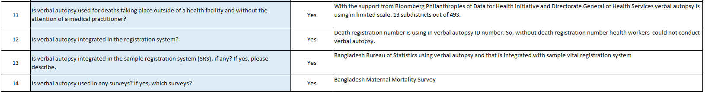
Figure 14: Summary “Verbal autopsy_summary.xlsx”
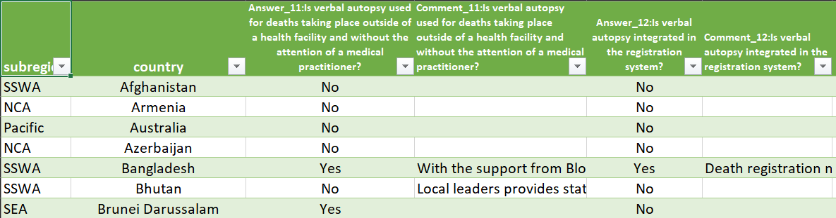
Apart from the two first columns, the following ones subsequently represent the answer and comment columns for each of these four questions.
Answer_11 (Column C)
The “Yes/No” answer to the question 11 on the use of Verbal autopsy in the country
Comment_11 (Column D)
The additional comment to the question 11.
Answer_12 (Column E)
The “Yes/No” answer to the question 12 on the integration of verbal autopsy in the registration system.
etc…

- Vital Statistics_summary.xlsx
This table is a visual and more compact summary of the information contained in the “Vital Statistics_db.xlsx” document. It focuses only on the Midterm answer to the status of each vital statistics target, as well as the target year. It is also in the “one line per country” format. If no answer was provided in the midterm column, the answer to the status for the baseline is taken as the answer.
Figure 15: Midterm questionnaire, sheet “5. Vital Statistics”
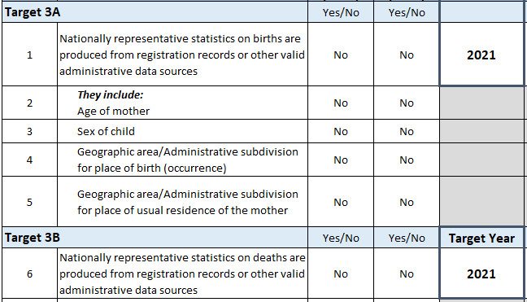
Figure 16: Summary “Vital Statistics_summary.xlsx”
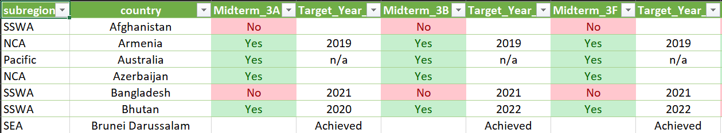
The columns alternate between a “Yes/No” answer indicating if the target has already been achieved or not, and a year reflecting the target that was or has been set, and this for each of the five targets.
Midterm_3A (Column C)
“Yes/No” answer to the question on the achievement of the target 3A as of the midterm (or the baseline if no answer for the midterm.
Target_Year_3A (Column D)
Year set as the objective to reach this target, or achievement.
Midterm_3B (Column E)
“Yes/No” answer to the question on the achievement of the target 3B
Etc…

- Report_summary_tables.xlsx
This document presents the different annex tables as shown in the CST report. It has 7 sheets corresponding each to one table of the report: Implementation steps, Birth registration, Death registration, Goal 2, Causes of death, Vital statistics (1) and Vital statistics (2). Counts on the number of answers can be found at the bottom of each tables. Notes on specific countries or values are marked by letters and explained below the tables. Some of this data has been filled or reviewed by hand, and might therefore vary from the other databases, mostly through deletion of some doubtful data.
Implementation step sheet
The first is a summary of the status of each of the eight implementation steps for every country. Only the last step, “Reporting to the Secretariat” has two columns, for the status of the baseline and midterm questionnaires respectively. The values can be “Yes”, “No”, “Plan” or empty.
Figure 17: Summary “Report_summary_tables.xlsx”, sheet “Implementation steps”
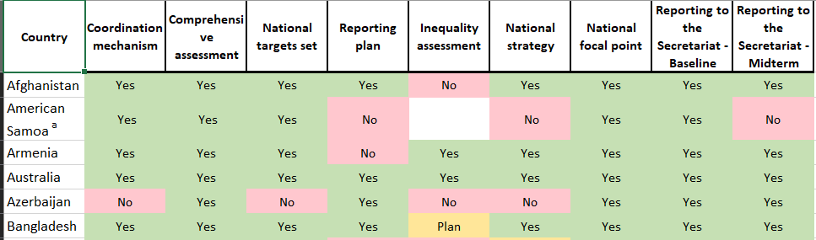
Birth registration sheet
Birth registration presents a summary of the results for targets 1A, 1B and 1C. This table, as well as the following, does not present data for all 62 countries but only for those that have answered either the baseline or midterm questionnaire, which at the moment accounts for 50 countries.
Figure 18: Summary “Report_summary_tables.xlsx”, sheet “Birth registration”
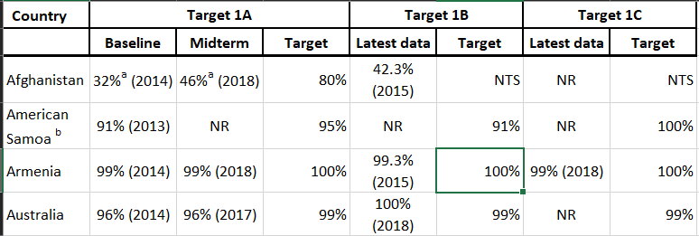
Target 1A has data for baseline (which was defaulted to 2014 if available) and midterm, when 1B and 1C only show the latest data. 1A and 1C were rounded to be integers. If the value was between 99 and 100%, it was truncated to 99% to avoid giving a false sense of completeness. For 1B, value from the SDG database was taken if it was dated from 2013 or after, and if there was no such data, or if it was from before 2013 then the administrative data was taken if any.
Missing values are noted “NR” for “No response” and if there is no target, it is marked “NTS” for “No target set”.
Death registration sheet
Remarks on death registration are essentially the same. It presents targets 1D and 1E. Target 1D is rounded in the same way that 1A and 1C are. Its baseline is also defaulted to 2014 if available.
Figure 19: Summary “Report_summary_tables.xlsx”, sheet “Death registration”
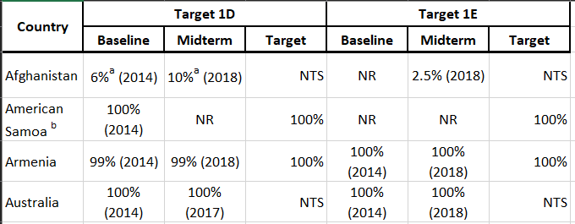
Goal 2 sheet
Goal 2 presents targets 2A and 2B, with simply their latest data, unrounded, and the target associated.
Figure 20: Summary “Report_summary_tables.xlsx”, sheet “Goal 2”
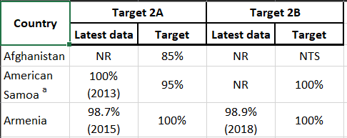
Causes of death sheet
For causes of death, targets 3D and 3E are presented. Considering the evolution of thought on verbal autopsy since the baseline, target 3E is not presented as a percentage of death external to the health system that are subject to verbal autopsy anymore. Instead, reflecting the midterm questionnaire’s evolution, it is presented as a “Yes/No” question. For the Midterm column, it corresponds to the answer to the contextual question 11 of the causes of death sheet of the questionnaire. Baseline and target have been interpreted from the baseline questionnaires’ answers. Baseline was considered as a “Yes” if there was an estimate of the percentage of deaths receiving verbal autopsy, and as a “No” if verbal autopsy was noted to not be used. Similarly, a numerical target was interpreted as a “Yes” for the target column, when a comment of the form “Not applicable”, etc…, was considered to be a “No”. Considering that the question of the target was not asked in the midterm, a missing target is not marked as “NTS” and is just left blank.

Figure 21: Summary “Report_summary_tables.xlsx”, sheet “Causes of death”
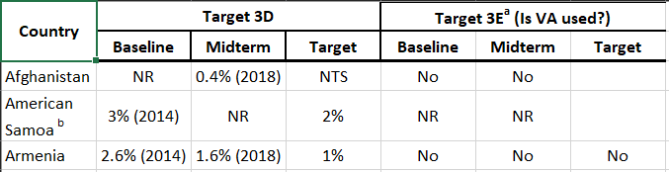
Vital Statistics (1) and (2) sheets
Vital Statistics (1) presents results for targets 3A and 3B, when Vital Statistics (2) contains targets 3F, 3G and 3H. The column baseline and midterm correspond to these columns in the midterm questionnaire for the main lines of these targets. For countries that have not answered the midterm questionnaire, these columns were left empty as it is hard to interpret the “Yes/No” answer from it. The Target column is for the target year. For countries that had written “Already achieved” or similar, or which had not provided any target but had answered “Yes” in the midterm, it was filled with “TA” for “Target achieved”. For countries that have answered “Yes” for the midterm but had set a target year, that year was left as such.
Figure 22: Summary “Report_summary_tables.xlsx”, sheet “Vital statistics (1)”
